Impact on “best practices” in Field, Lab and Data Collection of the Supplemental Guidance: Screening and Evaluating Vapor Intrusion, February 2023

Will Rice
Enthalpy Analytical
Technical Sales and Business Development
2323 5th St
Berkeley, CA 94710
T: 510-439-7877
E: will.rice@enthalpy.com

Background
In 2023 a guidance was released removing many quantitative tools, but providing more qualitative oversight. How we as an industry proceed in CA waterboard region 2 will set a tone for how the rest of the country will deal with an increasingly sensitive public opinion of developing on sites with known contamination.
Approach
The goal of this session is to engage and educate those responsible for site characterization with a new statewide update as of February 2023 in CA that pertains to Vapor Intrusion and has had input from state and regional waterboards, EPA and DTSC. Laboratory analytical and field sampling practices rely on each other being sound in their approach. In order to achieve this coordination and communication between labs, consultants, regulators and developers are warranted. Most notable this impacts approach to Attenuation Factor, a key component of characterization and achievable goals. That inspite of study by the DTSC the AF of .03 will be used means that indoor air and in particular sub slab characterization must change in order to create realistic goals.
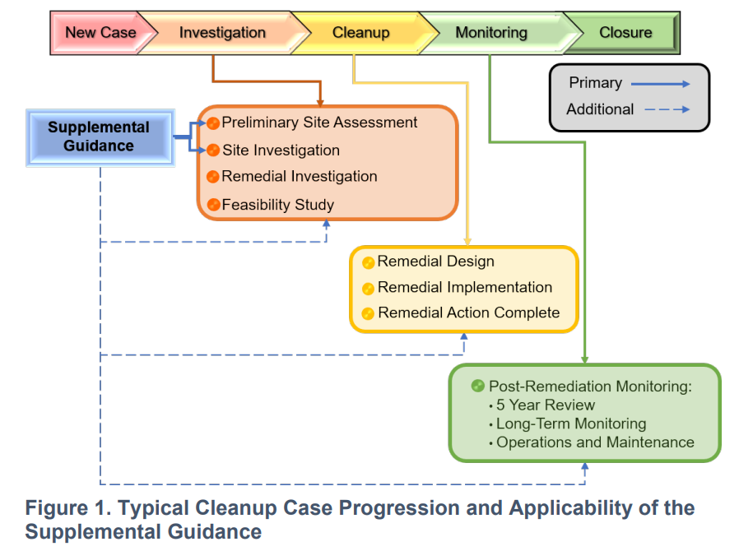
Attendees will get a clear explanation and examples of updates to field, lab and modeling practices can be utilized to strengthen their own work.
Lessons Learned
The conclusions will help inform best achievable practices in active and passive sampling moving forward given the 2023 February Final Guidance Update. It will be informed by laboratory practices but with the intention of still protecting project budget and timeline. The presentation is coming from a uniquely third party and unbiased perspective in that the laboratory intersects with developers, local authorities, consultants and regulatory agencies, without stake in property transaction decisions. The basic question answered by a risk assessment is “is my source truly sub-surface?”

